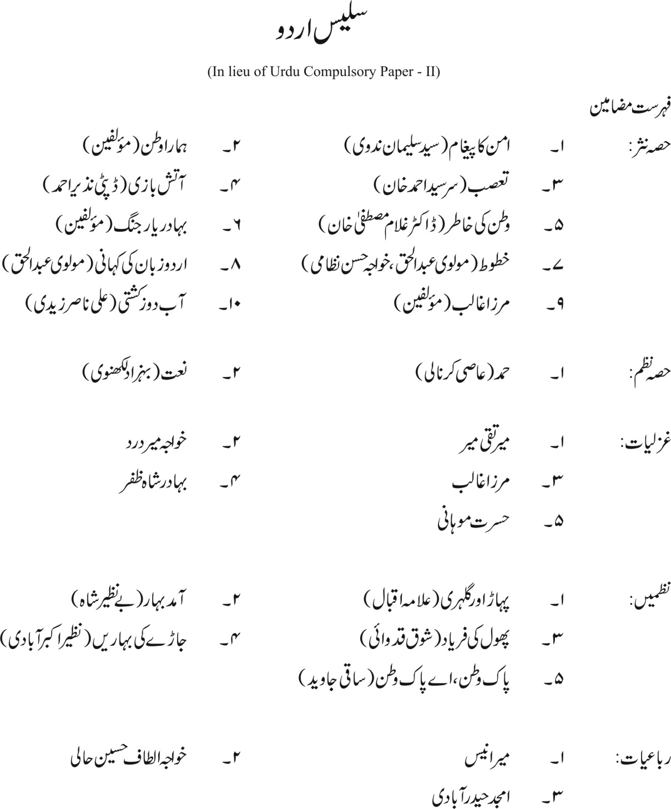

(75 Marks)

Graphic1

Graphic1

